- Solve the following inequalities and represent the solution on a number line hence state
the integral values 7x – 4 ≤ 9x + 2 < 3x + 14 (3 mks)

- Solve the quadratic equation using factorisation.
- 2x²+ x = 300 (3 mks)

- x²+4x-5=0. (3mks)

- a) Find the range of values x which satisfied the following inequalities simultaneously. (2 mks)
4x – 9 < 6 + x
8 – 3x < x + 4

b) Represent the range of values of x on a number line. (1 mark)
(a) Show by shading the unwanted region the area represented by, 4y < x +11, x≥1, x + y ≤ 9 and 5y >3x-3 on the grid provided (8 mks)

(b) Calculate the area of the enclosed region (2 mks)
- The diagram below shows a frustum made by cutting off a small cone on a plane parallel to the base of the original one. The frustum represent a bucket with the open end diameter of 36cm and diameter of the bottom 24cm. the bucket is 18cm deep as shown
(Take∏ =22/7
Calculate the:
(a) The vertical height of the original cone (3mks)

(b) Volume of the small cone cut off. (3mks)

(c) Volume of the original cone (2mks)

(d)The capacity of the bucket in liters (2mk)

- A straight line L1 passes through the points P (5 , -2 ) and Q ( 3,- 4 ) .
(a) Find the equation of L1 in the form a x b y c + = where a, b and c are integers. (3 marks)

(b) A line L2 passes through a point R( 0 , 3 ) and is perpendicular to L1.

(i) Find the equation of L2 in the form y m x + c = where m and c are constants. (2 marks)

(ii) Determine the point of intersection between L1 and L2. (3 marks)

(c) Another line L3 is parallel to L1 and passes through R. Find the x – intercept of L3. (2 mks)

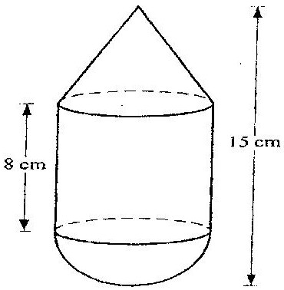
- The figure below is a model representing a storage container. The model whose total height is 15 cm is made up of a conical top, a hemispherical bottom and the middle part is cylindrical. The radius of the base of the cone and that of the hemisphere are each 3 cm. The height of the cylindrical part is 8cm.

(a) Calculate the external surface area of the model (6mks

(b) The actual storage container has a total height of 6 metres. The outside of the actual storage container is to be painted. Calculate the amount of paint required if an area of 20m² requires 0.75 litres of the paint. (4mks

7. The vertices of triangle PQR are P(O,O), Q(6, 0) and R(2, 4)
(a) Draw triangle PQR on the graph paper provided. (lmk)

b). Triangle P¹Q¹R¹ is the image of a triangle PQR under an enlargement scale factor, ½ and centre (2, 2). Write down the coordinates of triangle P¹Q¹R¹ and plot on the same grid.(3 mks)

c). Draw triangle P¹¹Q¹¹R¹¹ the image of triangle P¹Q¹R¹ under a positive quarter turn about points (1, 1). (3 mks)

d). Draw a triangle P¹¹¹Q¹¹¹R¹¹¹ the image of triangle P¹¹Q¹¹R¹¹ under reflection in the line y=l. (3mks)

